

Remote sensing monitoring of vine mortality in coastal areas threatened by salinization

## Phenomenon of salinity, the link with vine mortality

#### Salinization

Two sources: primary (natural process) and secondary (human impact)

For secondary: poor irrigation techniques (insufficient drainage, contaminated water, overexploitation of groundwater in coastal area, etc) or poor waste management can be the origin

In the Mediterranean region, 25% of irrigated agricultural land are affected by soil salinisation [[1]](https://www.zotero.org/google-docs/?LDlPxS)

Salinization can increase erosion, reduce water storage capacity and crusting on the surface.

#### Indicators of salinization [[1]](https://www.zotero.org/google-docs/?dzi4W1)

Field symptoms

Electrical conductivity of solution (EC)

Sodium absorption ratio (SAR)

Total Dissolved Solid (TDS)

Remote sensing indices

#### Mortality of the vine

## Remote sensing images

#### Use of remote sensing

One of the possible measurement is reflectance which is higher in the presence of salt [[2]](https://www.zotero.org/google-docs/?c9GRJN)

Easier to use image from the summer, as salt dissolve when there is rain

Using NDVI good to detect salinization but not to discriminate sale and alkaline soil

Aerial photography is better in small area for a bigger resolution

**Remote sensing** has been widely used as a source of environmental information for ecological **research**. ... Such maps have been used widely in ecological work. For example, studies of biodiversity related issues have often focused on land cover change as this is one of the greatest threats to biodiversity.

#### Data ressources

4 categories of satellites, which are separated according to different times.

Aerial photography (old image)

Landsat (from 1972)

SPOT (since 80's)

Sentinel quite recent (2000's) but lot of repetition

and more …

[Multi spectral images (RGB + IR)](http://ids.equipex-geosud.fr/web/guest/catalog1)

[SPOT ans Pleiades images (RGB + IR)](https://spatial.ign.fr/carte?searchTerm=&searchDateBegin=&searchDateEnd=&geometry=&searchPleiades=true&searchSPOT=false)

eos.com/landviewer/?lat=43.61070&lng=3.88090&z=11

Good table of the differents image sources for mapping salinity in [[2]](https://www.zotero.org/google-docs/?QbYxlH)

## The Tools

### QGIS

Include the integration of R script directly inside QGIS ([link](https://www.r-bloggers.com/qgis-open-source-gis-r/))

### R Studio

Lots of package that allow to do virtually anything (see [CRAN](https://cran.r-project.org/))

Some link about how to deal with spatial data with R:

* [link 1](https://www.jessesadler.com/post/gis-with-r-intro/)
* [link 2](https://cran.r-project.org/web/views/Spatial.html)

**Salinity Stress on vines**

Link: <https://www.scielo.br/scielo.php?pid=S0103-90162001000100021&script=sci_arttext>

(It is in Portuguese, but the important information I found I translated below)

<https://www.publish.csiro.au/cp/AR9921051>

<https://www.publish.csiro.au/FP/PP9770183>

“The results are in agreement with those obtained by Rambal & Winkel (1993), in which a direct relationship was established between water relations and plant growth, since stomatal conductance is directly affected by less water availability in the middle, which alters the transpiratory flow; this flow, responsible for the rise of water in the xylem and subsequent supply to the meristematic tissues, as well as leaves and stems. In addition, these results are in line with those found by Downton (1976); Prior et al. (1992), and Ludders & Golombek (1993), who found with the increase in salinity levels, a clear and drastic reduction in stomatal conductance, which led to a decrease in the partial pressure of intercellular CO2, negatively interfering in the assimilation of CO2 by photosynthetic apparatus, which compromised the performance of plants subjected to this environmental condition.

The first response of plants to water stress would be stomatal closure. This water stress, induced by saline stress (since with the addition of salts to the nutrient solution, water relations in the plant's growth environment are affected) acts to reduce the osmotic potential of the nutrient solution and, consequently, the potential water, limiting water absorption by plants. Plants subjected to water stress, due to the sensitivity of their root system, exhibit a rapid increase in stomatal resistance, accompanied by a change in the water potential in the leaf, indicating that this reaction is the result of the production of abscisic acid, a hormone that translocates from roots to branches and leaves (Pugnaire et al., 1993) ”

<https://www.sciencedirect.com/science/article/pii/S0378377401001159>

**Response of Sultana vines (*V. vinifera* L.) on six rootstocks to NaCl salinity exposure and recovery**

One-year-old Sultana (*Vitis vinifera* L.) vines, own-rooted and grafted on 41B, 110R, 140Ru, 1103P and SO4 were grown in sand–perlite mixture (1:1) irrigated with half-strength nutrient solution containing 5, 25, 50 and 100 mM of NaCl. Growth, tissue mineral content and leaf gas exchange response to salt treatment and subsequent recovery were examined over a 70-day period. Shoot growth, leaf area and total dry weight were significantly reduced (*P*<0.05) at all salinity levels. Tissue salt content increased significantly with increasing salinity, Cl− being always higher than Na+. Photosynthetic rate (*P*n) and stomatal conductance (*g*s) were greatly reduced by salinity and highly correlated with leaf Cl− content. Own-rooted vines exhibited higher dry matter production and photosynthetic rates than grafted vines, despite the higher Cl− and Na+ content. During recovery, vines previously treated with 50 and 100 mM NaCl exhibited photosynthetic rates and stomatal conductances similar to the control, although laminae Na+ and Cl− content continued to increase. Our results showed that own-rooted ‘Sultana’ vines (*V. vinifera*) can cope better with high salinity followed by those grafted on 1103P, 140Ru, 110R, SO4 and 41B rootstocks.

<https://www.sciencedirect.com/science/article/pii/S0378377413003351>

**Regulated deficit irrigation, soil salinization and soil sodification in a table grape vineyard drip-irrigated with moderately saline waters**

Irrigation with moderately saline waters may provoke soil salinization and sodification. The objectives of this three-year study were (1) to quantify these processes in two seedless table grapevines (*Vitis vinifera* cvs. Autumn Royal and Crimson) subject to a full irrigation and two regulated deficit irrigations (RDI, irrigated at 80% and 60% of net irrigation requirements from post-veraison till harvest) with 1.7 dS m−1 electrical conductivity irrigation waters, and (2) to assess the impact of soil salinization on grapevine's response. Soil samples were taken three times along each irrigation season and soil solution samples were extracted weekly by suction cups. Soil saturation extract electrical conductivity (ECe) and sodium adsorption ratio (SARe) were high in Autumn Royal (4.4 dS m−1 and 6.1 (mmol l−1)0.5) and very high in Crimson (7.0 dS m−1 and 8.6 (mmol l−1)0.5) due to relatively low leaching fractions (LF) (0.20 in Autumn Royal and 0.13 in Crimson). Soil solution salinity and sodicity were generally higher in the more severe RDI than in the full irrigation treatment. Soil salinity and sodicity generally increased along the irrigation seasons and decreased along the non-irrigation seasons. Salt accumulation or leaching and LF were significantly correlated, so that LF estimates could anticipate the required irrigation depths for soil salinity control. Grapevine yield declined with increases in soil salinity. Leaf Na concentrations were very low (<0.1%), but leaf Cl concentrations were higher and the maximum value of 0.61% measured in the more severe Crimson RDI treatment was within the interval reported as toxic in grapevine. Despite the water saving benefits of drip irrigation in combination with deficit irrigation strategies, its implementation in low-precipitation semiarid areas must be cautiously assessed and monitored because soil salinization and sodification may threaten the sustainability and profitability of these grapevine orchards irrigated with moderately saline waters.

<https://www.cabdirect.org/cabdirect/abstract/19910304876>

Transient soil salinization of irrigated Colombard/Ramsey grapevines was produced by substituting, for 4 different 2-month periods during the growing season, saline water (EC 3.5 dS/m) for irrigation water drawn from the River Murray (EC 0.5 dS/m). Irrigation with saline water produced a transient increase in the EC of the 'root weighted saturated soil solution'. This increase caused a decline in leaf water potential and an increase in leaf petiole Na+ and Cl- contents. There was no statistically significant effect on vine vegetative growth (pruning weights) or yield. These results are contrary to those predicted by the Murray-Darling Commission model which is designed to quantify vine yield losses due to salinity.

<https://www.sciencedirect.com/science/article/pii/S1631069107003411?via%3Dihub>

**In vitro culture: a simple and efficient way for salt-tolerant grapevine genotype selection**

The present work was carried out with the objective of studying the salt tolerance (NaCl) of different vine genotypes grown in vitro and, at the same time, to develop a fast and inexpensive test for salt tolerance. The genotypes most tolerant to the treatment with salt and asenin, followed by the Saouadi and Sakally varieties moderately used and, finally, all the rootstocks (1103P, 41B and SO4) and with a Razegui variety, with high sensitivity. By exhibiting good behavior under in vitro salt treatment and high vigor, a local Tunisian variety (ie Asli) can be grown on its roots without roots, and a wild Sejnene variety can be used as a rootstock.

<https://www.sciencedirect.com/science/article/pii/S0166248108704823>

**Impact of Climatic Change on Soil Attributes: Influence on salinization and alkalinization**

**SCENARIO 1** Potential soil salinity caused by climatic changes: France and also several areas in the Italian and Balkan Peninsulas are particularly exposed to potential salinity due to the increasing aridity. It must be noted that if the increase in the average annual temperature will surpass 1 ºC, the increase in salinity will not be linear, but rather exponential. **SCENARIO 2** Potential soil salinity caused by sea-level elevation: Good probability of sea-level rise due to global climatic changes in the next 50 years. If sea-level rise surpasses the values taken for granted in this study, the extension of potential salinity will again not be linear, but will increase to an even higher degree. **SCENARIO 3** Existing and potential soil salinity caused by irrigation: Salt accumulation in the soil originating from the salt in irrigation water, Salt accumulation in the soil originating from the salt in rising salty groundwater. As far as soil salinization from irrigation water is concerned there are acceptable regulations for quality control of irrigation water.

The three scenarios, which have been discussed and demonstrated above, represent the main processes leading to the hazard of secondary salinization in Europe. However, they do not exhaust all the possibilities of this phenomenon, which may develop due to other factors like: changes in cropping pattern, intensive use of chemicals, changing farm management, etc.

<https://www.sciencedirect.com/science/article/pii/S0303243417300417>

**Retrospective 70 y-spatial analysis of repeated vine mortality patterns using ancient aerial time series, Pléiades images and multi-source spatial and field data**

This study aimed at performing a historical and spatial tracing of vine mortality patterns using a long time-series of aerial survey images (1947–2010), in combination with recent data: soil apparent electrical conductivity EM38 measurements, very high resolution Pléiades satellite images, and a detailed field survey. Within-field terroir units were obtained from a support vector machine classifier computed on the spectral bands and NDVI of Pléiades images, EM38 data and morphometric data.

Three steps: (i) performing such historical and spatial tracing of vine mortality patterns, over the span of 70 y using a long term series of remotely-sensed images; (ii) digitally mapping within-field terroir units using multiple spatial layers; (iii) then testing the mapped mortality patterns against terroir units and their current soil and vine condition parameters.

Vine condition was assessed through field observations aiming at characterizing vine vigour, and the NDVI computed from the summer Pléiades image. The soils are of the type Mediterranean Red (chromic luvisols), coluvic calcisols, sandstones, fluvisols and regosols.

Pléiades satellite images with resampling at 2 m and 0.5 m-resolutions in multispectral and panchromatic modes.

From 1972–2015, the total area of zones with missing vines increased from 0.18 to 1.01 ha, with a temporary decrease from 1996 to 2001 (0.86–0.68 ha) due to the plantings of patches of Grenache vines in plot ‘holes’ in the early-nineties. For a total of about 17700 initial vine plants, the present-day percentage of missing vines was estimated at 16.9%, which fall in the category of high mortality rate according to a former regional study conducted across the Languedoc viticultural area. The map of missing vines frequency revealed repeated patterns of higher vine mortality over time.

It had a spatial negative correlation with the planting age, which is logical considering that the oldest vines were still alive.

It highlighted the tight relationships between vine mortality, soil type, past land use, and long term soil management, particularly in terms of soil organic carbon.

<http://www.sciencedirect.com/science/article/pii/S004896971733509X>

**Landscape evolution and agricultural land salinization in coastal area: A conceptual model**

This study aimed to propose a conceptual model for water fluxes in a coastal area affected by salinity, which can help to identify the relationships between agricultural landscape evolution and actual salinity

**“**Within the context of land degradation, soil salinization is a major threat.”

“Estuaries can be places that favor the salinization process.”

For the methodology of landscape data: Annual and monthly mean temperature and rainfall time-series were constructed. The Orb River discharges were measured from 1965 to 2015 at Béziers-Tabarka hydrological station (43°22′N; 3°10′E) by DREAL-Languedoc Roussillon. Climatic and discharge trends were calculated using the 10-year moving average applied to the annual data with R-software. An important issue was to analyze the landscape structure and land use evolution, through interviews with elderly farmers.

Results: In order to explain actual salinization, was used landscape evolution analysis to identify developments responsible for the system disequilibrium. Among the changes cited by farmers is the evolution of landscape structure and the decrease in annual rainfall and river discharge. This disclosure by farmers demonstrated that for them the main issue in soil salinity management is the total available amount of fresh water for salt leaching from the soil root zone to the ditch network.

Considering the seasonality of the Mediterranean climate, the consequences of water deficit during the dry season include the following: (i) increased evaporation, leading to salt precipitation on the soil profile or on the soil surface, (ii) increased capture of water from the plant, leading to drying conditions in the root zone, (iii) increase in capillary forces acting on the soil body, favoring water and salt transfer in soil profiles from saturated to unsaturated zones (from the deepest soil horizon to the root zone)

<https://www.alice.cnptia.embrapa.br/alice/bitstream/doc/1111518/1/TeseArtenioCabralBarreto2019.pdf>

**MODELING SOIL SALINITY WITH THE USE OF TECHNIQUES REMOTE SENSING**

(The work is in Portuguese, but I tried to put the important information below ... but if you have any questions, I can translate other parts of the thesis)

“Initially, a preliminary analysis of the perimeter was carried out, using satellite imagery and soil sampling in the field. The objective of this analysis was to identify through the production fault images and to verify the variation of the salt concentration in depth, identifying the best correlation between the salinity levels and the response of spectral indices, as well as to perform a temporal analysis of the vigor of the vegetation in the study area. A case study was carried out to evaluate the spectral index that best represents the salinity variation within the irrigated perimeter and to evaluate how the special resolution of the satellite images and the vegetation interfere in the determination of the salinity.

The band of the MSI / Sentinel2 satellite that best correlates with soil salinity was the green band (B03) with a determination coefficient of 59.85%, and all bands of the visible one shows a significant correlation with salinity, soil determined by the use of TIRS / Landsat8 images did not present a good correlation. The elevation of the terrain also showed a significant correlation with 57.21%. The saline areas with exposed soil presented a spectral behavior different from the other areas, with a higher reflectance in the visible region and based on these analyzes it was possible to develop 15 spectral indices of salinity, being the best SA7 used for the mapping of the salinity of the place and validated with a R² of 83.84%. Vegetation indices were not good for soil salinity mapping, and the characteristic vegetation of saline areas (halophytes) presents a distinct reflectance characteristic of the other types of vegetation found in the area, mainly with a higher reflectance in the visible region.”

“The increase in electrical conductivity in the soil promotes a reduction in the expected yield of the plantation.”

“The reflectance of the ground, not only from visible light, but also from all others lengths of the optical spectrum range, is a property that derives from the behavior spectrum of mineral, organic and fluid constituents that, combined, make up soils. The spectral responses of the different types of soils are normally associated with electromagnetic radiation absorption processes. Besides the mineral composition, particle size, moisture and their organization also play an important role in the reflectance properties of soils, and spectra provide important information about the physicochemical characteristics of the soils.”

In the figure we can see the variation of reflection on different surfaces, with different effects salts, where reflection increases as the concentration of salts in the soil increases

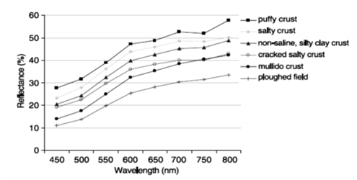

“The better the spatial resolution of images, the better the determination of the concentration of salts in the soil. images from the MSI / Sentinel 2 Satellite, dated July 25, 2018, which has a **spatial resolution of 10 m**. The images used (without the presence of clouds) for the development of models and field collections were carried out in July, during the dry season. The images were submitted to the process of atmospheric correction using the Dark-Object Subtraction (DOS) technique, using the software Quantum Gis. Sampling was georeferenced, in the UTM coordinate system, with SIRGAS 2000 datum, located in zone 24 S. The Sentinel2 Multispectral Instrument (MSI) has 13 spectral bands: four bands with spatial resolution of 10 meters, six bands with 20 meters and three bands with 60 meters (ESA, 2018). All bands (13) were submitted to the analysis of correlations of Pearson between his spectral response and the salinity obtained at the collection point and determined the its coefficient of determination (R²). The bands with the best correlations were used to create the models. Models with low salinity (up to 4 dSm-1) and models for higher salinity (greater than 4 dSm-1).

The bands that showed the best correlations were the bands of the visible (Blue, Green and Red) and Red Edge 1. These, in turn, showed a high correlation between soil salinity and elevation of the terrain. The green band (B3) was the one that had the best result presenting a coefficient of determination (R²) of 59.85%. The bands 57 12 and 11 (SWIR 1 and SWIR2) had the lowest correlations (r² = 2.46 and 4.39% respectively). Some authors (Allbed et al., 2014; Arasteh, 2010; Mariappan, 2010) report the superiority of the red band (B4) in correlating with salinity, using images ETM / Landsat. Ibrahim (2016) found a better correlation of the Adsorption Ratio of Sodium - RAS with red (B4) and blue (B2) bands. Bouaziz et al. (2011), at work developed in northeastern Brazil, analyzing the correlation of MODIS satellite bands with soil salinity, concluded that the best correlation was found through the Near Infrared - NIR (B4).”

**Vine Growing calendar**

<https://www.evineyardapp.com/blog/2016/02/04/annual-grapevine-growth-cycle-and-vineyard-management-calendar/>

<https://www.puyfromage.com/chateau/en/from-the-vines-to-the-wine/know-how-the-work-of-the-vine/the-vineyard-work-annual-calendar/>

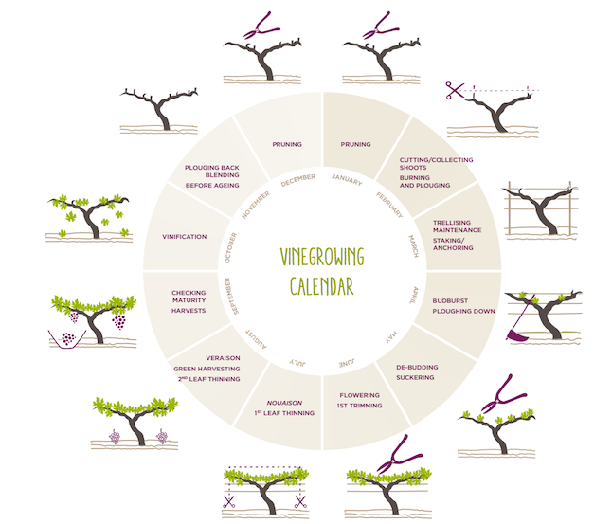

**Grapevine phenology**

<https://winesvinesanalytics.com/features/article/196082/Grapevine-Phenology-Revisited>

Phenology is the study of natural changes or growth and natural development of an organism and its relation to seasonal changes in climate. In viticulture, we are mostly referencing a limited number of key growth stages that are used for benchmarks for implementation of vineyard-management tasks including canopy management, vineyard nutrient monitoring and pest and disease prevention. The growth stages or phenology events most commonly referred to include bud burst, bloom, fruit set, cluster closure, véraison and fruit maturity (harvest).

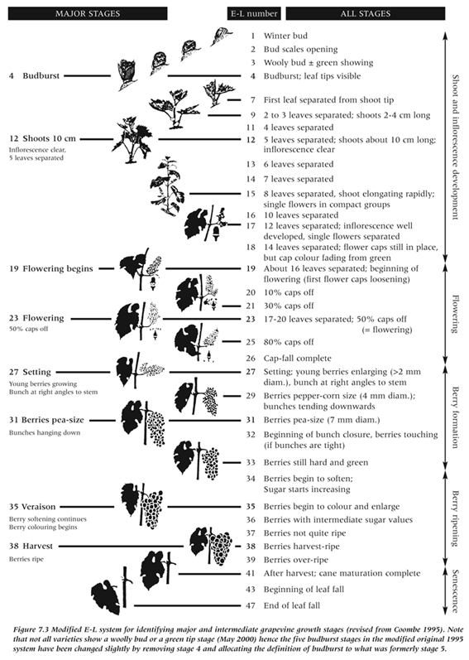

<https://www.researchgate.net/publication/278719325_Principles_of_Arthropod_Pest_Management_in_Vineyards/figures?lo=1>

**Principles of Arthropod Pest Management in Vineyards**

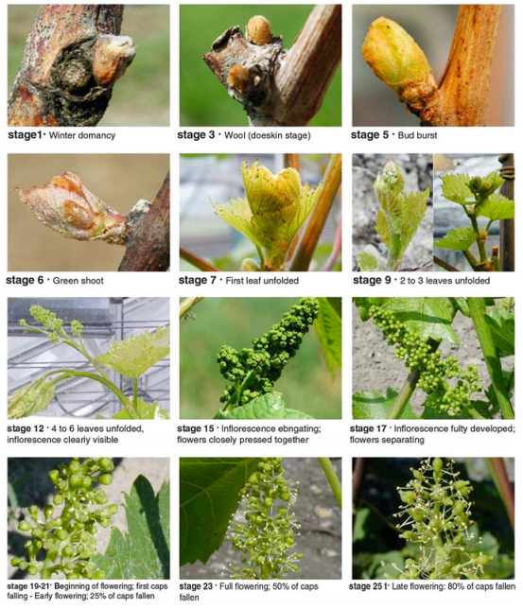

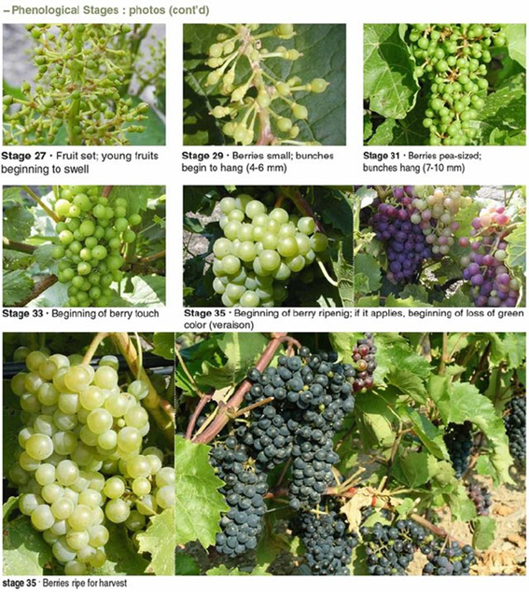

<https://enoviti-hanumangirl.blogspot.com/2012/01/eichhorn-lorenz-grapevine-phenology.html>

**Eichhorn-Lorenz Grapevine Phenology**

